It’s a service marketplace where individuals can post needed services like walking dogs, lawn mowing and many other services in the platform. Both customers and service providers have profiles for general details and past reviews. This platform mostly targets students who need quick cash. All needed services will show up based on the user’s location.

**List of requirements**

* The users (customers and service providers) should be able to sign up with their name, email, and phone numbers.
* Create accounts and make profiles.
* There should be a way to verify as student to use the apps
* They should be a homepage with a list of services available
* There should be an option to change passwords and emails
* Customers and service providers should be able to update and modify their profiles and the services they provide at any time.
* Customers should be able to see and apply for the services
* Service providers should be able to see, approve and deny applications sent by customers
* In addition to the filter option customers, should be provided with a search bar to manually search for services.
* There should be a filter option to help find specific service based on the distance and service preferences
* The Filter option should allow customers to sort services based on reviews
* There should be an option for customers to contact service providers via email vice versa
* There will be review sections for customers and service providers to view and write reviews
* There should be an option to make payment online (bank transfer) or in person after a service has been completed.
* There should be a history section to see what jobs the customer has done recently.

Other requirements

* The app or website should be user friendly and easy to use
* The web app should be compatible with desktop (Windows, Mac, and Linux) and also Android and iOS
* The web app needs to be fast, robust, and reliable
* If possible, the web app should be able to operate offline

**Design prototype**

Back

NAME

LOGO

Location

**Register**

Enter your phone number

Create password

Confirm password

Enter your Age

Gender

Enter your email

Enter your name

I’m not a member?

Sign up

NAME

LOGO

**Continue**

Enter your email

CREATE YOUR PROFILE

Find the perfect *job* to make some quick cash while studying

**Popular:**

**Search**

I

NAME

LOGO

Enter Service Description

**Submit**

Enter Title

**User Stories – David**

* I want to post my dog so people can see my dog they’ll walk
* As the business I want to be able see the intensity of what I’ll be working
* I want to know how much I’ll be paid immediately
* I want to be able to chat with the client/ businessperson
* I want to be able to see multiple people that offer the service, so I can compare
* I want to be able to have payment options
* I want to know my location when walking my dog
* I want to be able to post reviews
* I want to be able to view other reviews
* As a service provider I want to be able to post dogs available to walk
* As a service provider I want customers that require my service to be able to contact me directly on the platform about my services
* As a customer I want to see all the skills/services available for hire on the platform clearly listed out
* As a customer I want a search button to quickly search for a service I am looking to hire
* As a service provider I want the platform to guide me how to advertise my services on the platform so I can start earning money
* As a service provider I want to be able to apply for needed services posted by individuals on the platform

# USER STORIES: [Rawan]

* As a daily user, I want to be able to access my account with both day and light mode, so I can comfortably browse.
* As a user, I want two-step verification to the registration process to add an extra layer of security.
* As a service provider, I want to be able to make my purchase via different methods, so I can choose which one fits me the best.
* "As a user, I want to be able to securely log in to the system so that my information can only be accessed by me."[login]
* As a User, I want to contact the service provider privately, so that I can enquire about the service. [chatting in the app]
* As a User, I would want to negotiate with the service provider, so we both be on the same page.
* As a user I want to know the availability of the service, so that I can manage my schedule.
* As a user, I want to negotiate the price…
* As a user I want to see if the service provider is reliable, so then I feel safe and secure to go on with the service. [reviews]

User stories – Alex

As a user – a student using the system

As a client – the person asking for the job to be completed

* As a user I want to be able to view a range of jobs easily so that I can choose and apply for the job that best suits my skills.
* As a user I want to I want to easily be able to change my password should I forget my password, or it not be a secure.
* As a user I want to be able to easily update my profile so that I can easily display my skills and abilities.
* As a user I want to easily be able to see the distance/location of the job so that I can arrange how to get there and complete it.
* As a client I want to be able to easily post a range of jobs so that I can get my tasks completed to help me out.
* As a client I want to be able to leave a review on the users so that if they completed the job well, I could recommend them to other users.
* As a client I want to be able to easily repost old jobs like cutting the grass so that I don’t have to go through the process of filling the job out again.
* As a client I want to be able to view the reviews of the clients before I accept their applications, so I know if they will be good at completing the job they have applied for

User Stories – Lukas

* As a customer, I want to be able to view reviews on job hosts and people taking the jobs and see how many jobs they have hosted/completed.
* As a customer, I want to be able to view what jobs are in my area and how far they are from me.
* As a customer, I want to be able to see if equipment for the job is provided.
* As a customer, I want to be able to change my password.
* As a customer, I want to be able to view a person’s profile.
* As a customer, I want to be able to chat to the person who has posted to job ad to get more details.
* As a user, I want my address to be hidden from customers until they take the job.

**Methodology**

**Agile Methodology**

The reason I believe agile methodology is the best choose for our project is because it is flexible not rigid/ fixed and it was development to handle scenarios where requirements can change.

Its also offers an iterative process that allows you to identify the immediate highest priority, implement it (write code test, integrate with any other code, write documentation). Then review what the next highest priority currently is and implement that.

**Difference between agile and Waterfall**

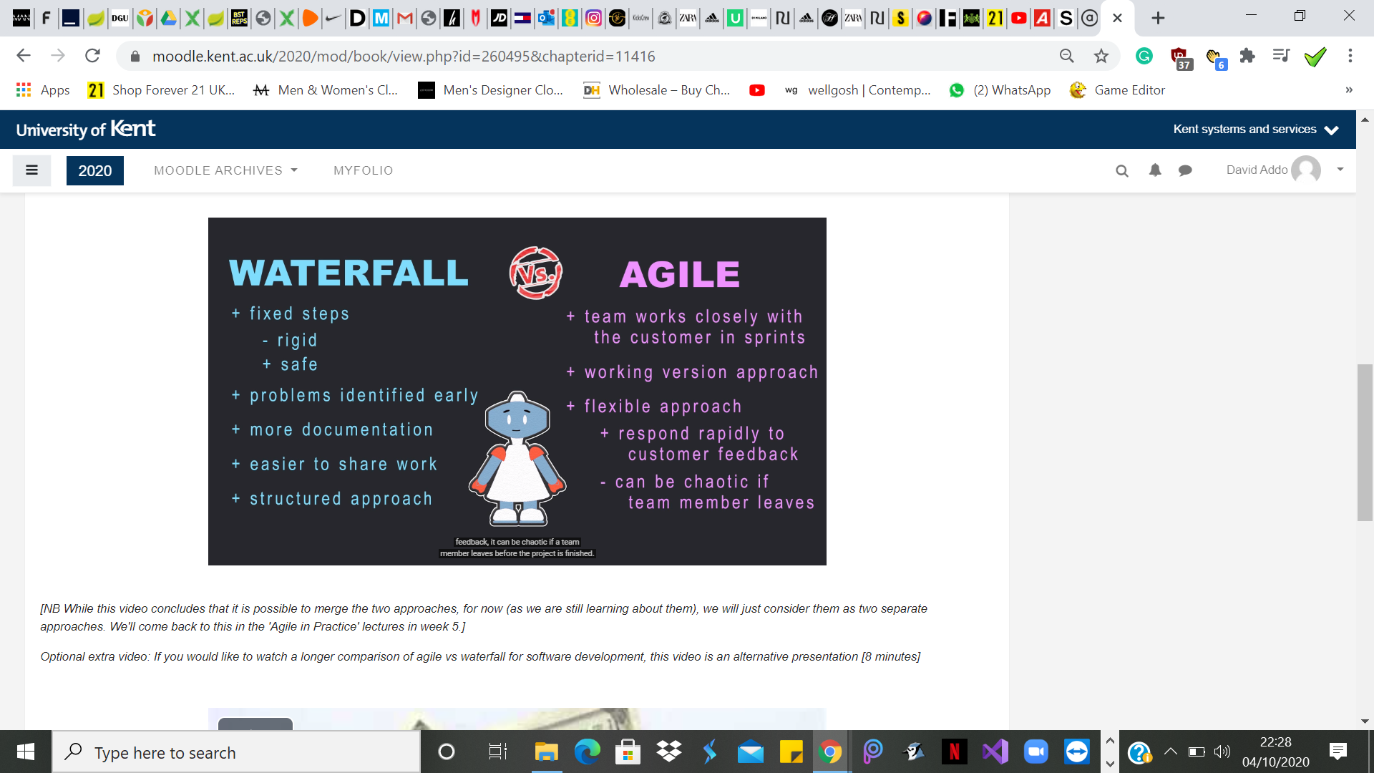

**Frameworks**

**React**

Is an open-source JS library

Responsible for the view part of the application what the user sees

React using a virtual DOM to fill in the data HTML DOM this allows faster and quick responsiveness

It consists of multiple components that output a small piece of html that is visible to the user.

Uses a domain specific language called JSX which is a combination of JS and HTML